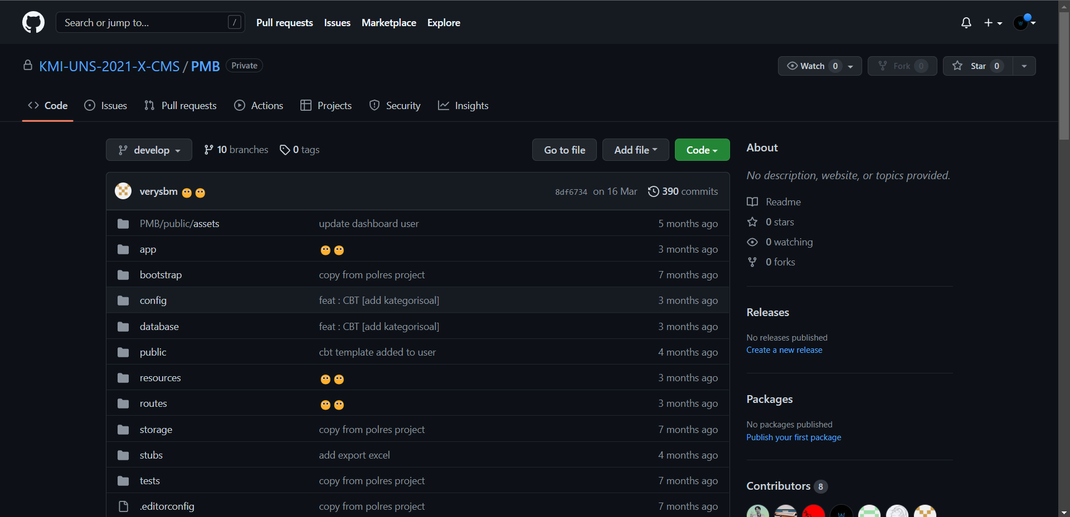

<https://github.com/KMI-UNS-2021-X-CMS/PMB.git>

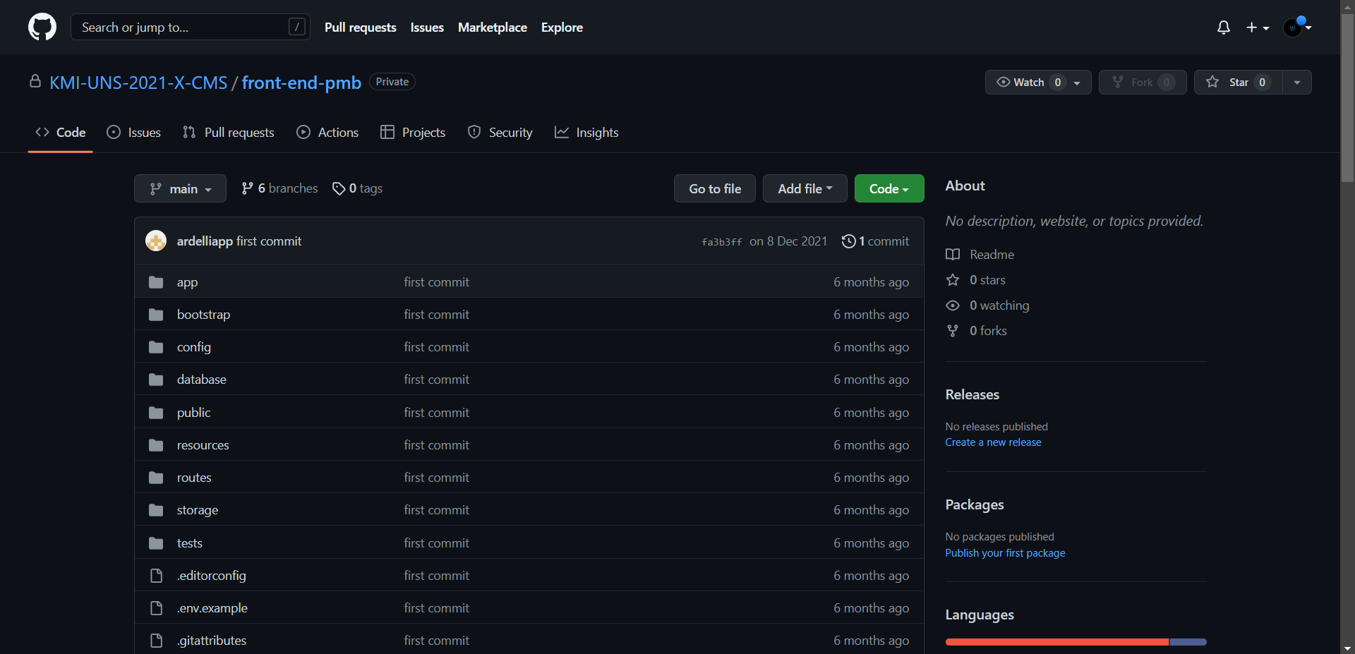

<https://github.com/KMI-UNS-2021-X-CMS/front-end-pmb.git>

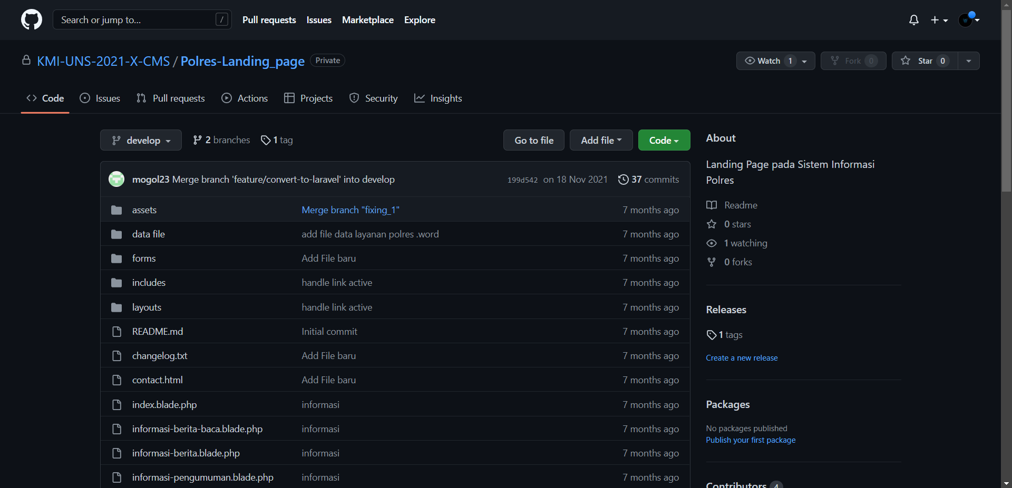

<https://github.com/KMI-UNS-2021-X-CMS/Polres-Landing_page.git>

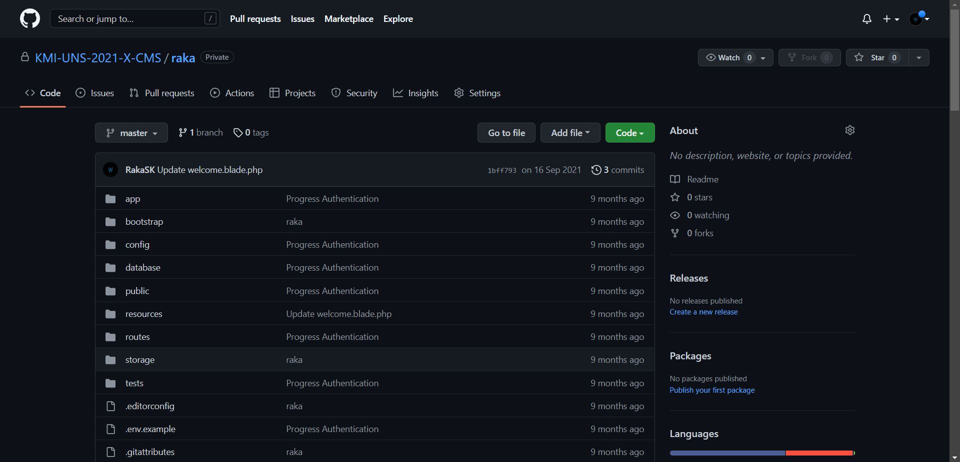

<https://github.com/KMI-UNS-2021-X-CMS/raka.git>